 |  | CAPGEMINI FS-SBU  A-1, Technology Park, Talwade, Pune – 412114. INDIA
ASSOCIATE PARTNERS TEAM |  | Background Verification
GAP001EVF02 Version 3.0 |  | WEF October 1, 2006
 | BACKGROUND VERIFICATION |  | ANNEXURE 1

Information Release Form

I hereby authorize Capgemini FS-SBU (or a third party agent appointed by the Company) to contact any former employers as indicated above and carry out all Background Checks not restricted to education and employment deemed appropriate through this selection procedure. I authorize former employers, agencies, educational institutes etc. to release any information pertaining to my employment/education and I release them from any liability in doing so.

I confirm that the above information is correct to the best of my knowledge and I understand that any misrepresentation of information on this application form may, in the event of my obtaining employment, result in action based on company policy.

First Name | Middle Name | Last Name
Sudipto |  | Saha

Date | D | D | / | M | M | / | Y | Y | Y | Y
Date | 0 | 2 | / | 0 | 4 | / | 2 | 0 | 2 | 4
Signature | 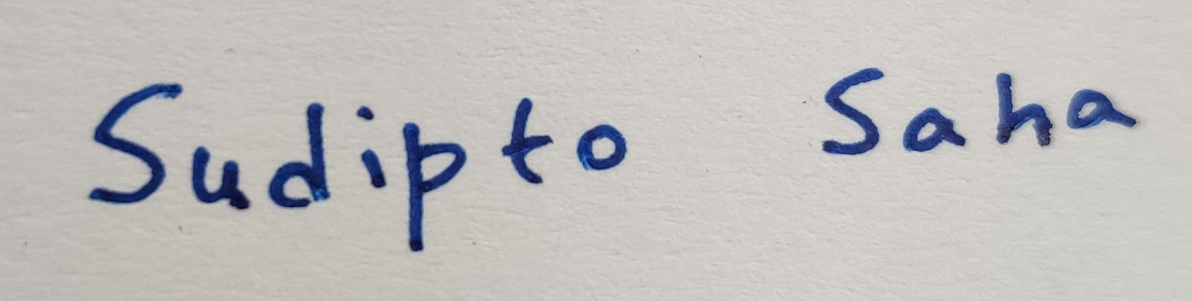

CAPGEMINI FS-SBU
A-1, Technology Park, Talwade, Pune – 412114. INDIA
ASSOCIATE PARTNERS TEAM |  | Background Verification
GAP001EVF02 Version 3.0 |  | WEF October 1, 2006
 | BACKGROUND VERIFICATION |  | ANNEXURE 2

PERSONAL DETAIL
Title
  Mr. | ✓ | Ms.
Candidate’s Name | First Name Middle Name Last Name  Sudipto Saha
Know by other name (if any)
[e.g. Maiden / Former Name]
Father’s Name | Subrata Kumar Saha
Date of Birth (DD/MM/YY) | D | D | / | M |  | M | / | Y |  | Y | Y | Y
Date of Birth (DD/MM/YY) | 0 | 4 | / | 0 |  | 2 | / | 1 |  | 9 | 9 | 6
Permanent Address | 139/3, Nagendra Nath Road, Kolkata, West Bengal - 700028 |  |  |  |  |  | Period of stay: 1996 – Present
Landmark Details | Beside Lokenath apartment, near Jorapukur, Satgachi - Battala
Current Address | 139/3, Nagendra Nath Road, Kolkata, West Bengal - 700028 |  |  |  |  |  | Period of stay: 1996 – Present
Landmark Details | Beside Lokenath apartment, near Jorapukur, Satgachi - Battala
Contact Number | +919088521045, +917003166253
E-mail ID | sahasudipto336@gmail.com, ecesudiptosaha4103@gmail.com
Passport/ PAN / SSN | PO589938 |  |  |  | FVAPS2904B

EDUCATION DETAILS*
- Mention the detail ONLY of the highest degree obtained.
- Details of degree COMPLETED are to be mentioned. (PURSUING degree details are not required)
College or Institute Name | Dr. B. C. Roy Engineering College, Durgapur
College or Institute Address | G8VR+QM8, Durgapur, West Bengal 713206
University Name | Maulana Abul Kalam Azad University of Technology
University Address | BF Block, Sector 1, Bidhannagar, Kolkata, West Bengal 700064
Name of Degree | Bachelor of Technology
Period | From (DD/MM/YYYY) | To (DD/MM/YYYY)
Period | 19/08/2014 | 01/06/2018
Seat Number (ID/Roll Number) | 12000314103
Qualification Gained | ✓ Full Time  Part Time

CURRENT EMPLOYMENT
Employer’s Name | Publicis Sapient
Employee ID / Code | 10104287
Employer’s Address | 2870, Building - Virgo, Bagmane Constellation Business Park, Marathahalli, Bengaluru, Karnataka 560037
Employer’s Phone No. | 080 6128 0000
Employer’s Fax No.
Employment Status | ✓ Full Employment  Contract (If on contract through an Outsourcing Agency, please provide Name, Address & Telephone Number of the agency)
Designation / Position Held | Senior Associate L1 |  |  | Department
Reason for Leaving | Better opportunity
Date of Joining: |  |  | Date of Leaving:
  D | D | / | M | M | / | Y | Y | Y | Y
  2 | 2 | / | 0 | 6 | / | 2 | 0 | 2 | 2
  D | D | / | M | M | / | Y | Y | Y | Y
Name of Supervisor / Manager:  Sulabh Gupta |  | Contact Number:  +919990358330 |  |  | E-mail Address:

PREVIOUS EMPLOYER
Employer’s Name | Capgemini
Employee ID / Code | 114594_FS
Employer’s Address | Rajiv Gandhi Infotech Park, Plot No.14, Phase III MIDC SEZ, Village Man Taluka Mulshi, Haveli, Pune, Maharashtra 411057
Employer’s Phone No. | 020 6699 1000, bgv.in@capgemini.com
Employer’s Fax No.
Employment Status | ✓ Full Employment  Contract (If on contract through an Outsourcing Agency, please provide Name, Address & Telephone Number of the agency)
Designation / Position Held | Associate Consultant |  |  | Department
Reason for Leaving | Better opportunity
Date of Joining: |  |  | Date of Leaving:
  D | D | / | M | M | / | Y | Y | Y | Y
  2 | 0 | / | 0 | 3 | / | 2 | 0 | 1 | 9
  D | D | / | M | M | / | Y | Y | Y | Y
  2 | 0 | / | 0 | 6 | / | 2 | 0 | 2 | 2
Name of Supervisor / Manager: Annapurna Prathipati |  | Contact Number:  +91 90596 74211 |  |  | E-mail Address:

